Clock
# Source: AI Source: Provided by: [Data Path: Persons Table -> ID Column: 1, Name_En Column: Motasem Essam] -> From: [ChatGPT] on [7/17/2026]
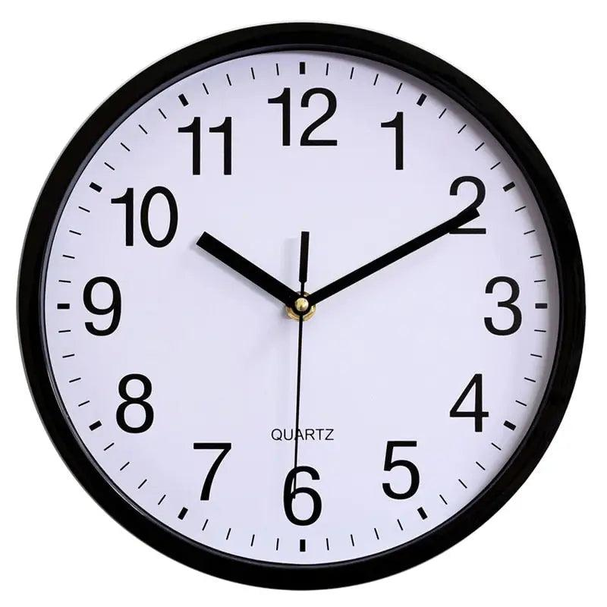
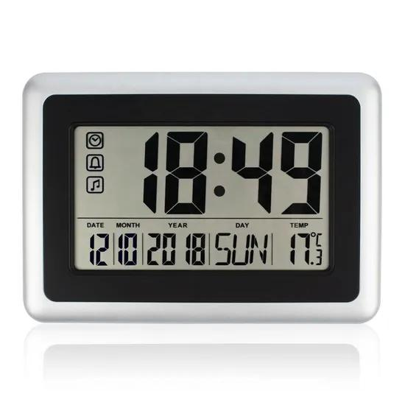
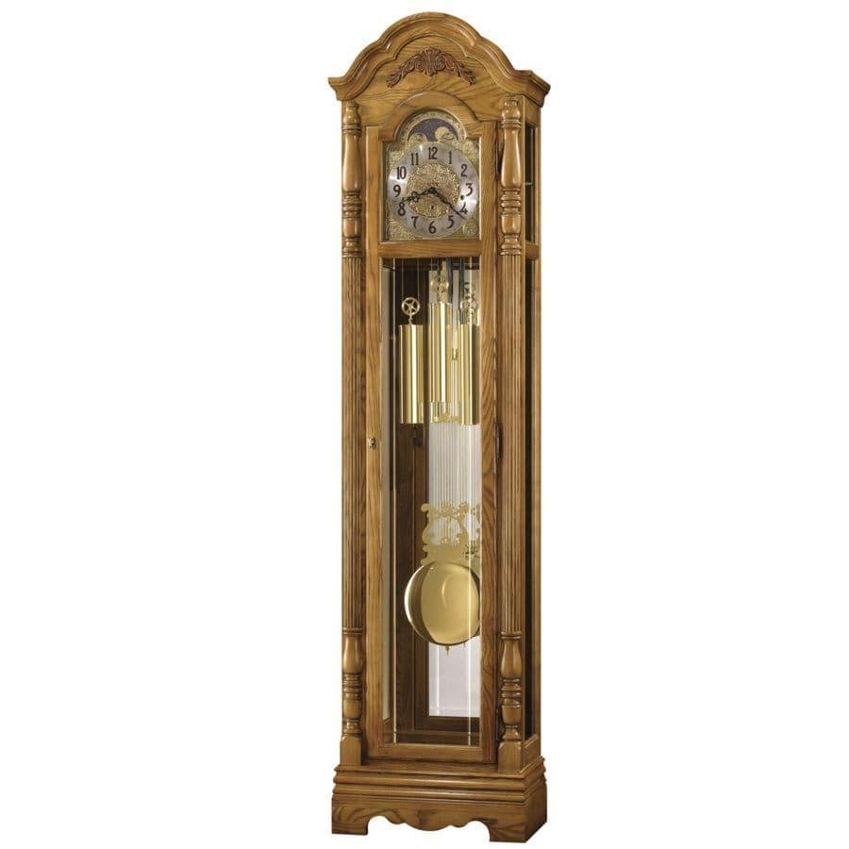
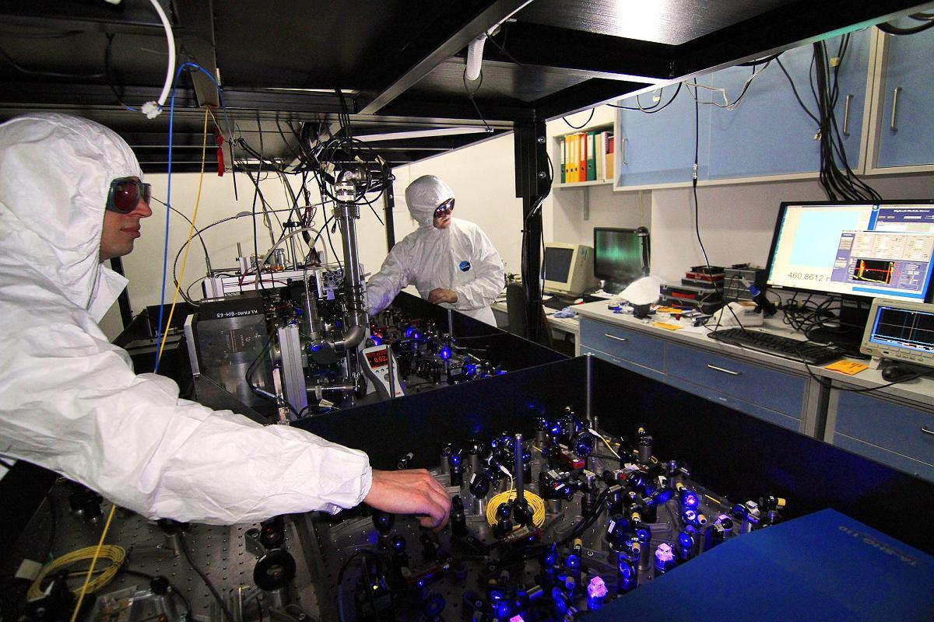
A Clock is a time-measuring instrument used to indicate the current time by measuring and displaying the continuous passage of time. Clocks are among the oldest and most important measuring instruments, serving essential roles in daily life, science, engineering, navigation, communication, transportation, and industry.
Unlike a stopwatch, which measures elapsed time, a clock continuously displays the current time of day.

Definition
# Source: AI Source: Provided by: [Data Path: Persons Table -> ID Column: 1, Name_En Column: Motasem Essam] -> From: [ChatGPT] on [7/17/2026]
A Clock is a time-measuring instrument that continuously measures and displays the current time using a mechanical, electrical, electronic, or atomic timing mechanism.

Purpose
# Source: AI Source: Provided by: [Data Path: Persons Table -> ID Column: 1, Name_En Column: Motasem Essam] -> From: [ChatGPT] on [7/17/2026]
A clock is used to:
- Display the current time.
- Coordinate daily activities.
- Schedule events.
- Synchronize transportation.
- Control industrial processes.
- Support scientific experiments.
- Provide standard time references.

Principle of Operation
# Source: AI Source: Provided by: [Data Path: Persons Table -> ID Column: 1, Name_En Column: Motasem Essam] -> From: [ChatGPT] on [7/17/2026]
Different clocks use different timing mechanisms:
- Mechanical clocks use gears, springs, pendulums, or balance wheels.
- Quartz clocks use a quartz crystal oscillator vibrating at a stable frequency.
- Digital clocks count electronic timing pulses generated by quartz oscillators.
- Atomic clocks use the natural vibration frequency of atoms (such as cesium) as an extremely precise time reference.

Main Components
# Source: AI Source: Provided by: [Data Path: Persons Table -> ID Column: 1, Name_En Column: Motasem Essam] -> From: [ChatGPT] on [7/17/2026]
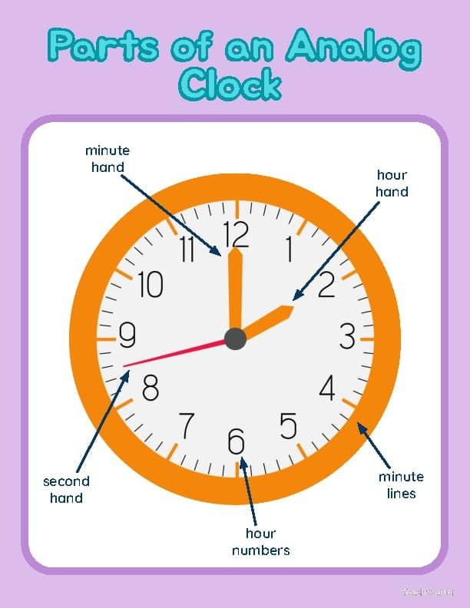
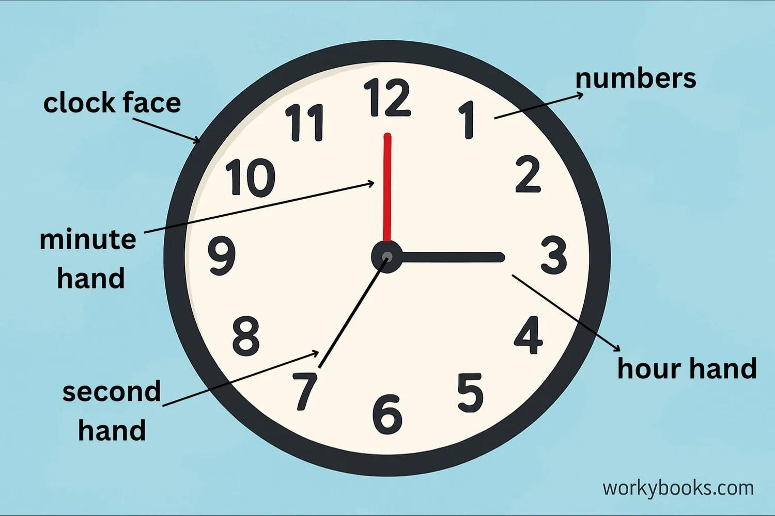
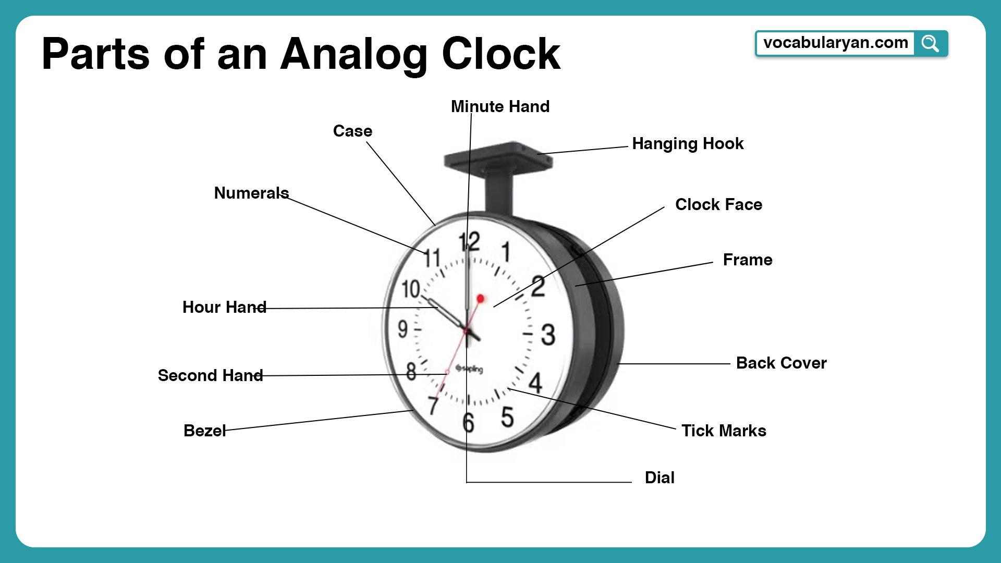
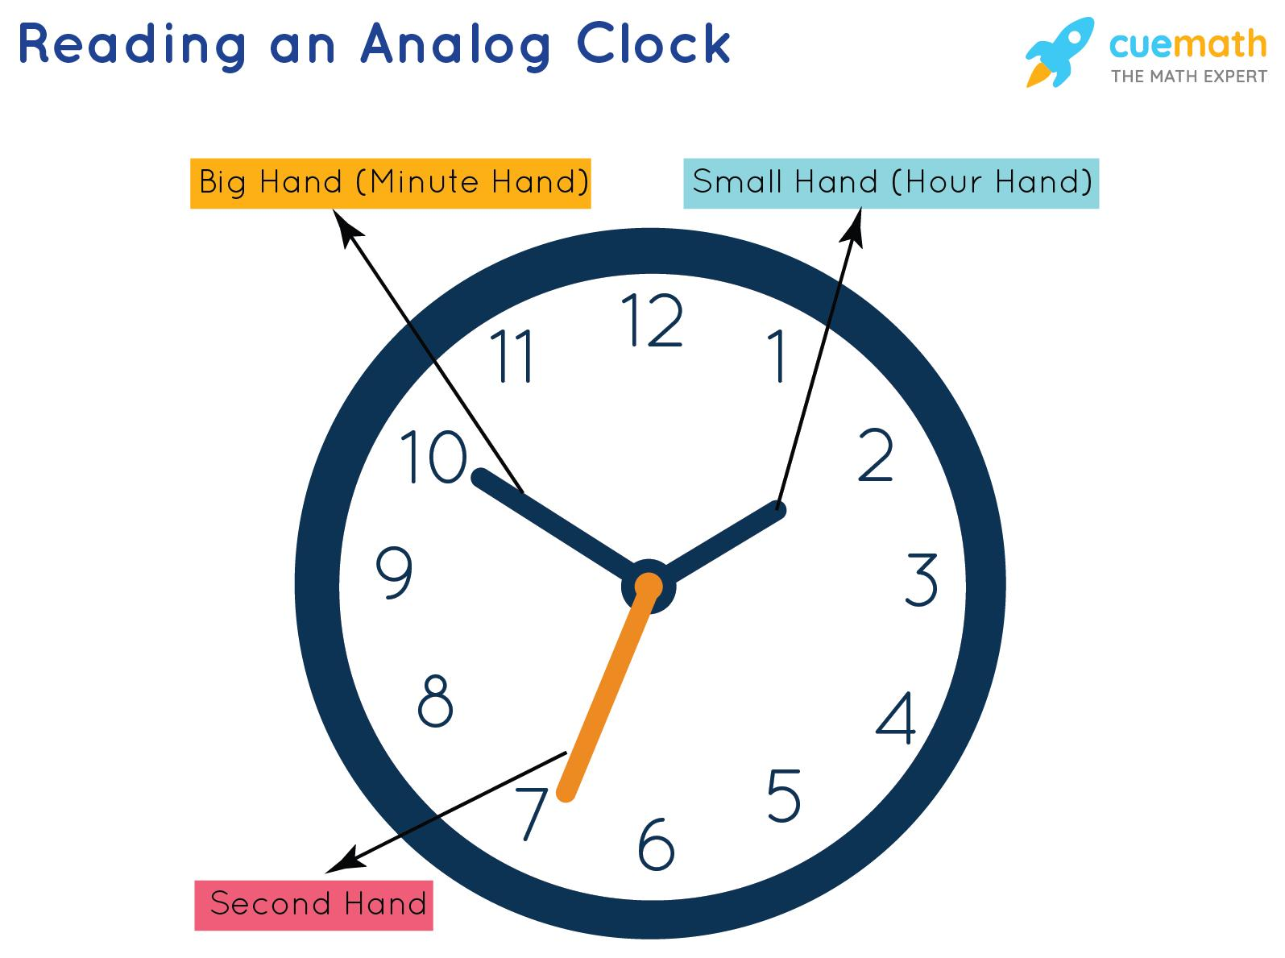
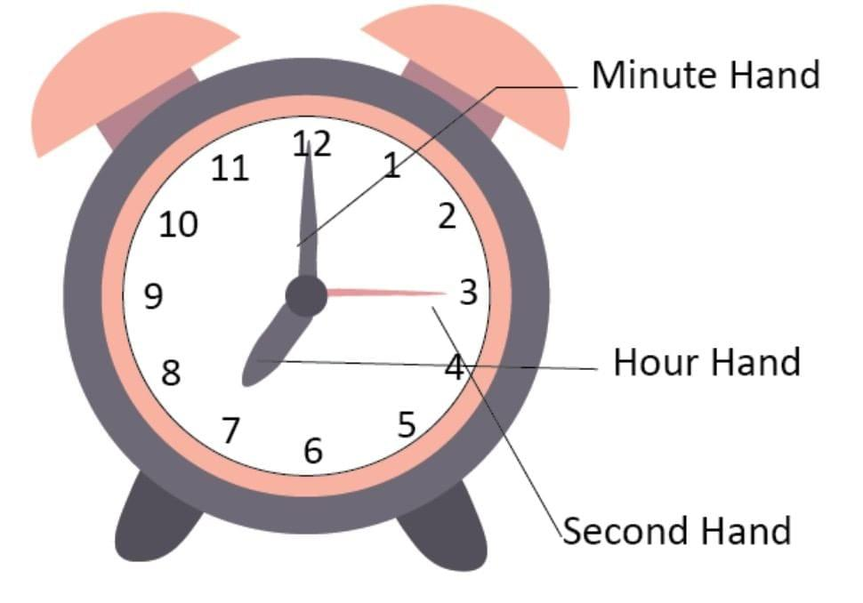
Typical components include:
- Clock face (dial or display)
- Hour hand
- Minute hand
- Second hand (analog clocks)
- Quartz oscillator or mechanical movement
- Power source (battery, mains, or spring)
- Control buttons (digital clocks)

Types of Clocks

1. Analog Clock
# Source: AI Source: Provided by: [Data Path: Persons Table -> ID Column: 1, Name_En Column: Motasem Essam] -> From: [ChatGPT] on [7/17/2026]
Description
Displays time using rotating hands on a circular dial.
Features
- Hour hand
- Minute hand
- Second hand
- Numbered or marked dial
Applications
- Homes
- Schools
- Offices
- Public buildings

2. Digital Clock
# Source: AI Source: Provided by: [Data Path: Persons Table -> ID Column: 1, Name_En Column: Motasem Essam] -> From: [ChatGPT] on [7/17/2026]
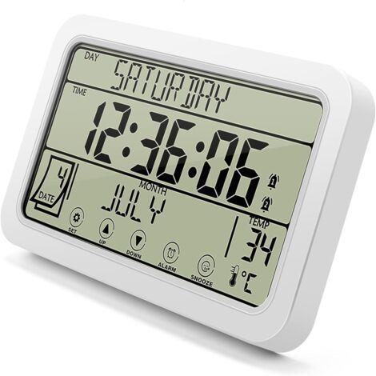
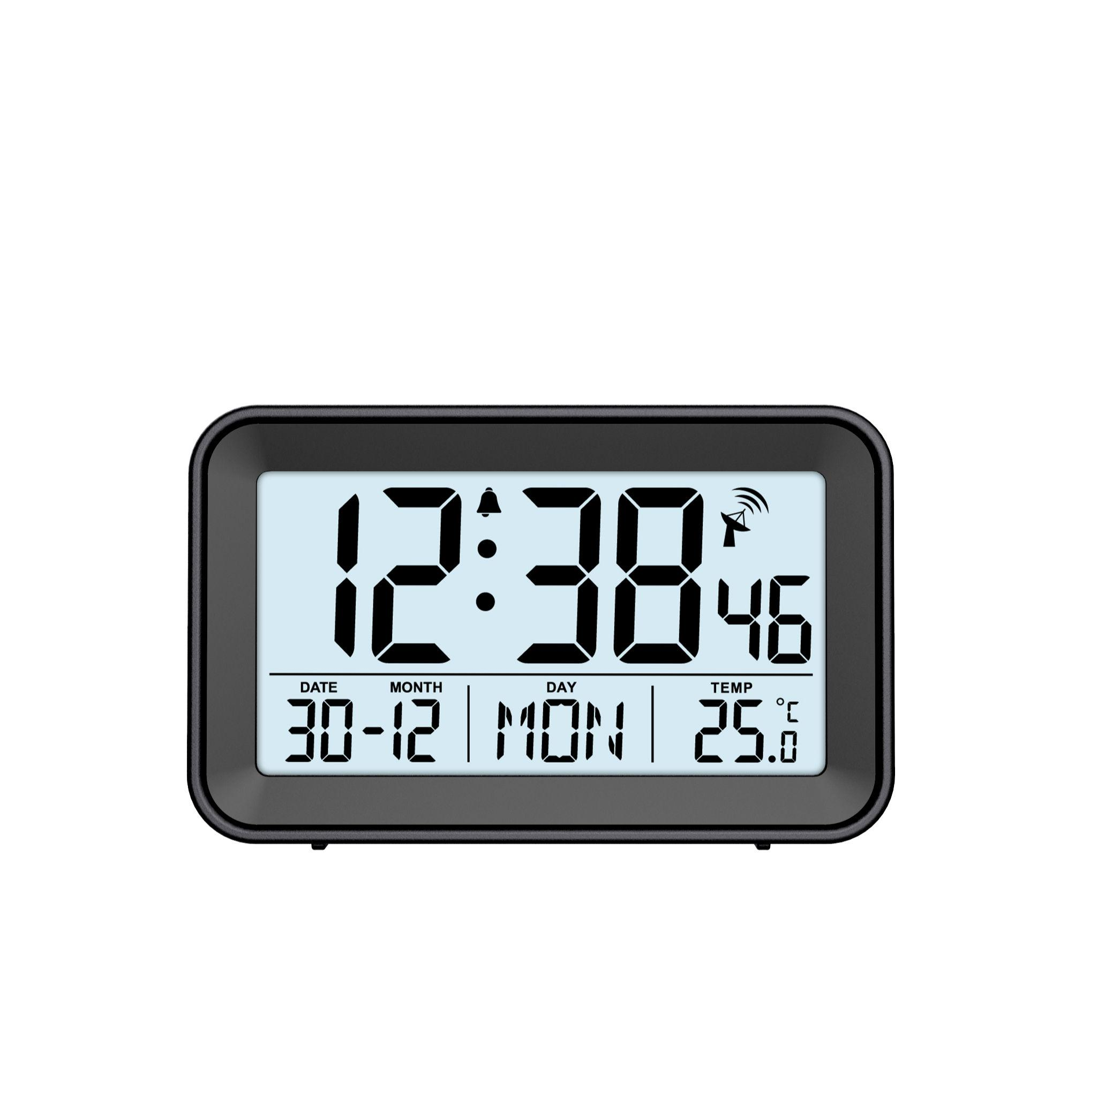
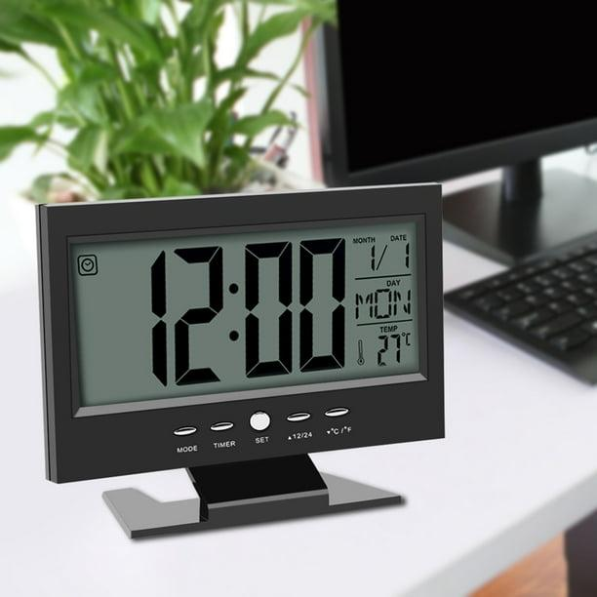
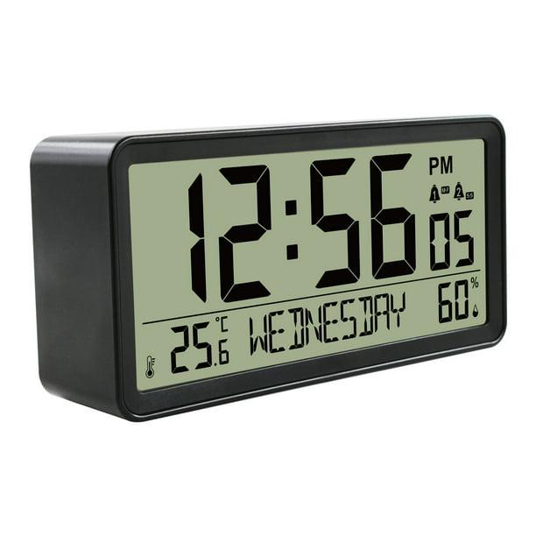
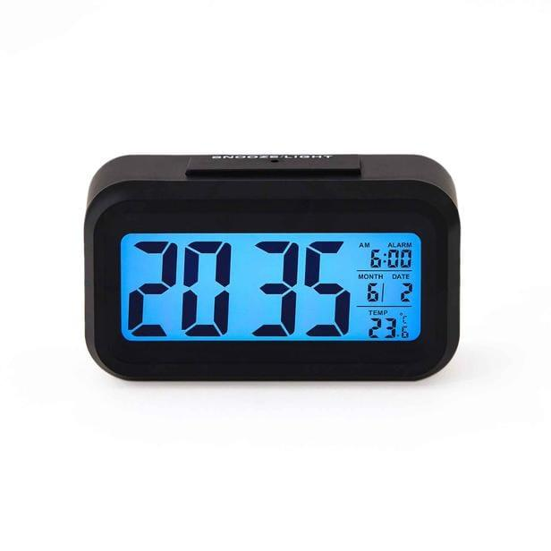
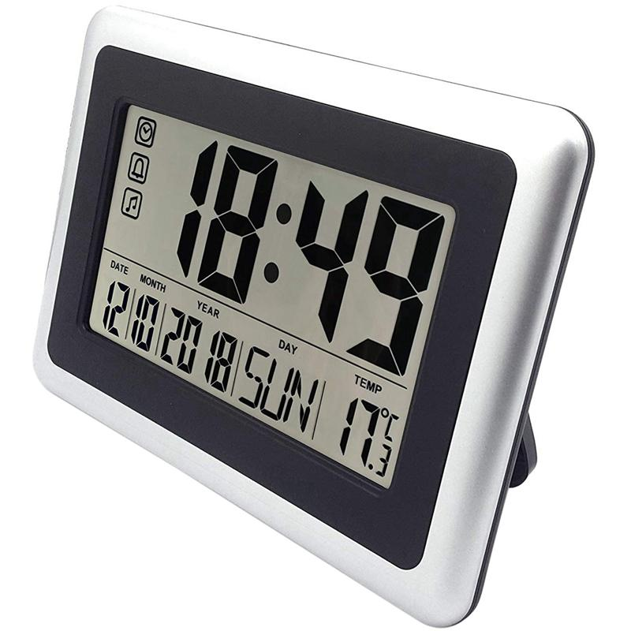
Description
Displays time numerically on an LCD or LED screen.
Features
- 12-hour or 24-hour display
- Alarm
- Date display
- Automatic timekeeping
Applications
- Homes
- Computers
- Laboratories
- Industry

3. Mechanical Clock
# Source: AI Source: Provided by: [Data Path: Persons Table -> ID Column: 1, Name_En Column: Motasem Essam] -> From: [ChatGPT] on [7/17/2026]
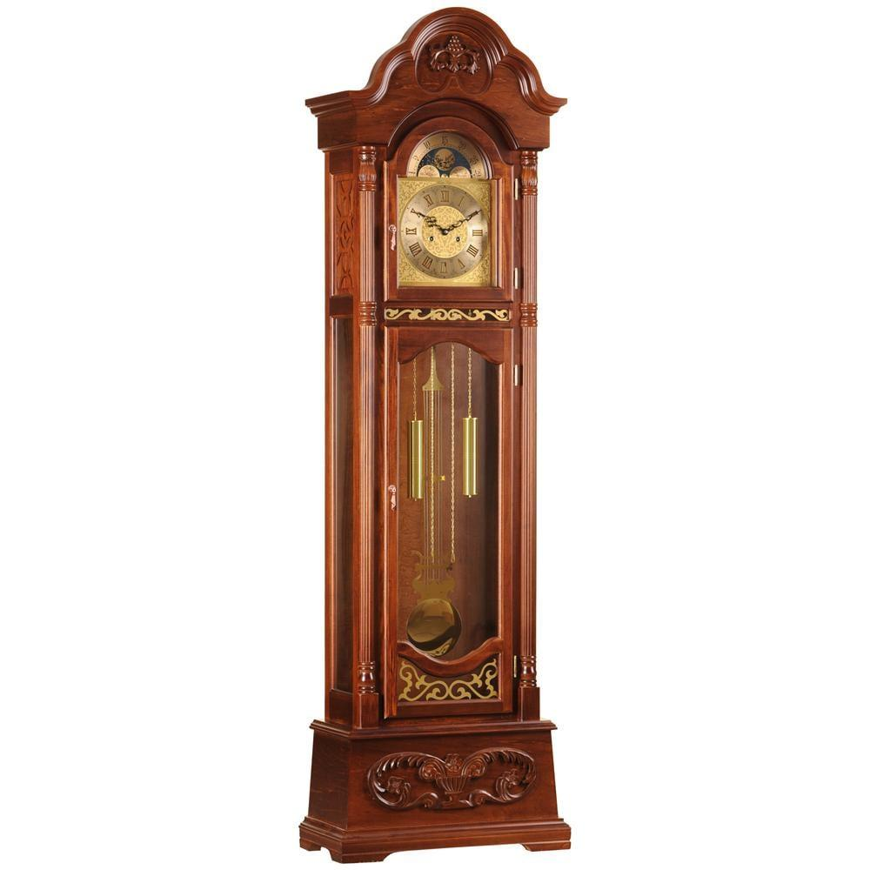
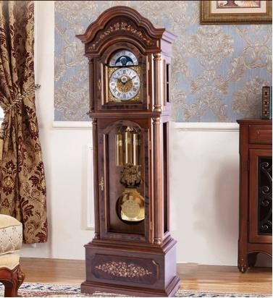
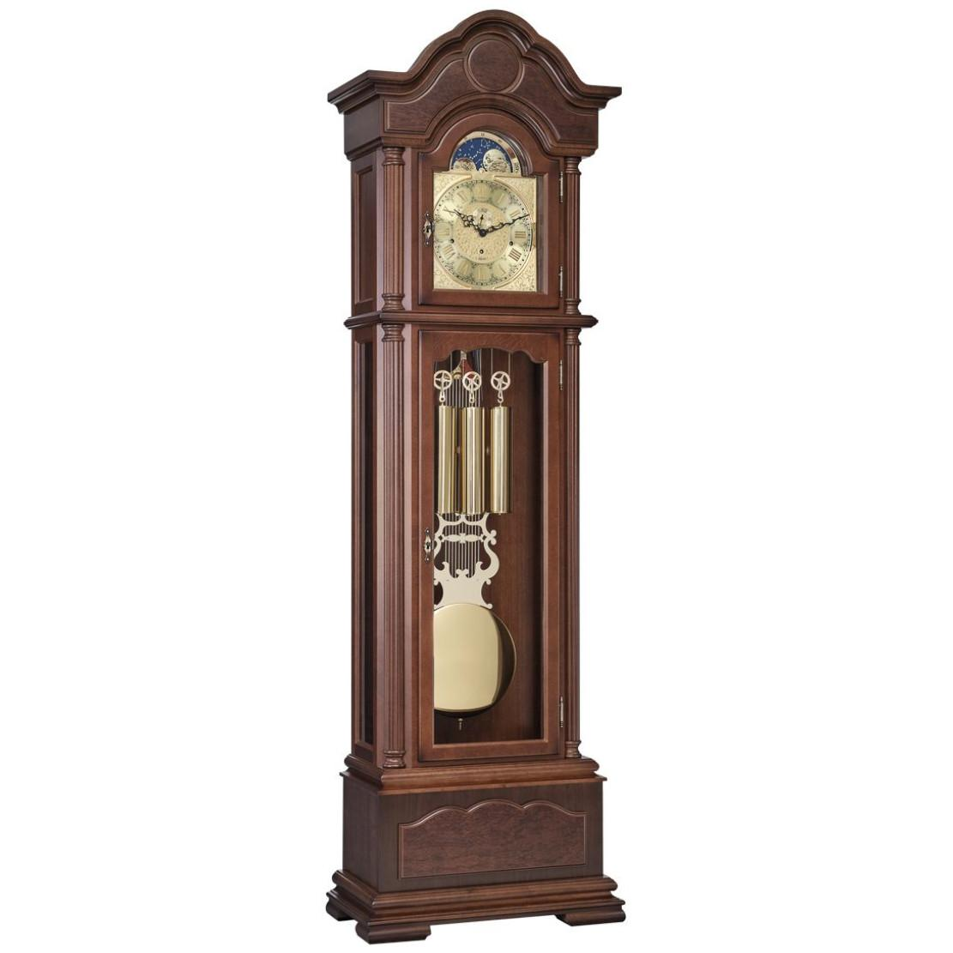
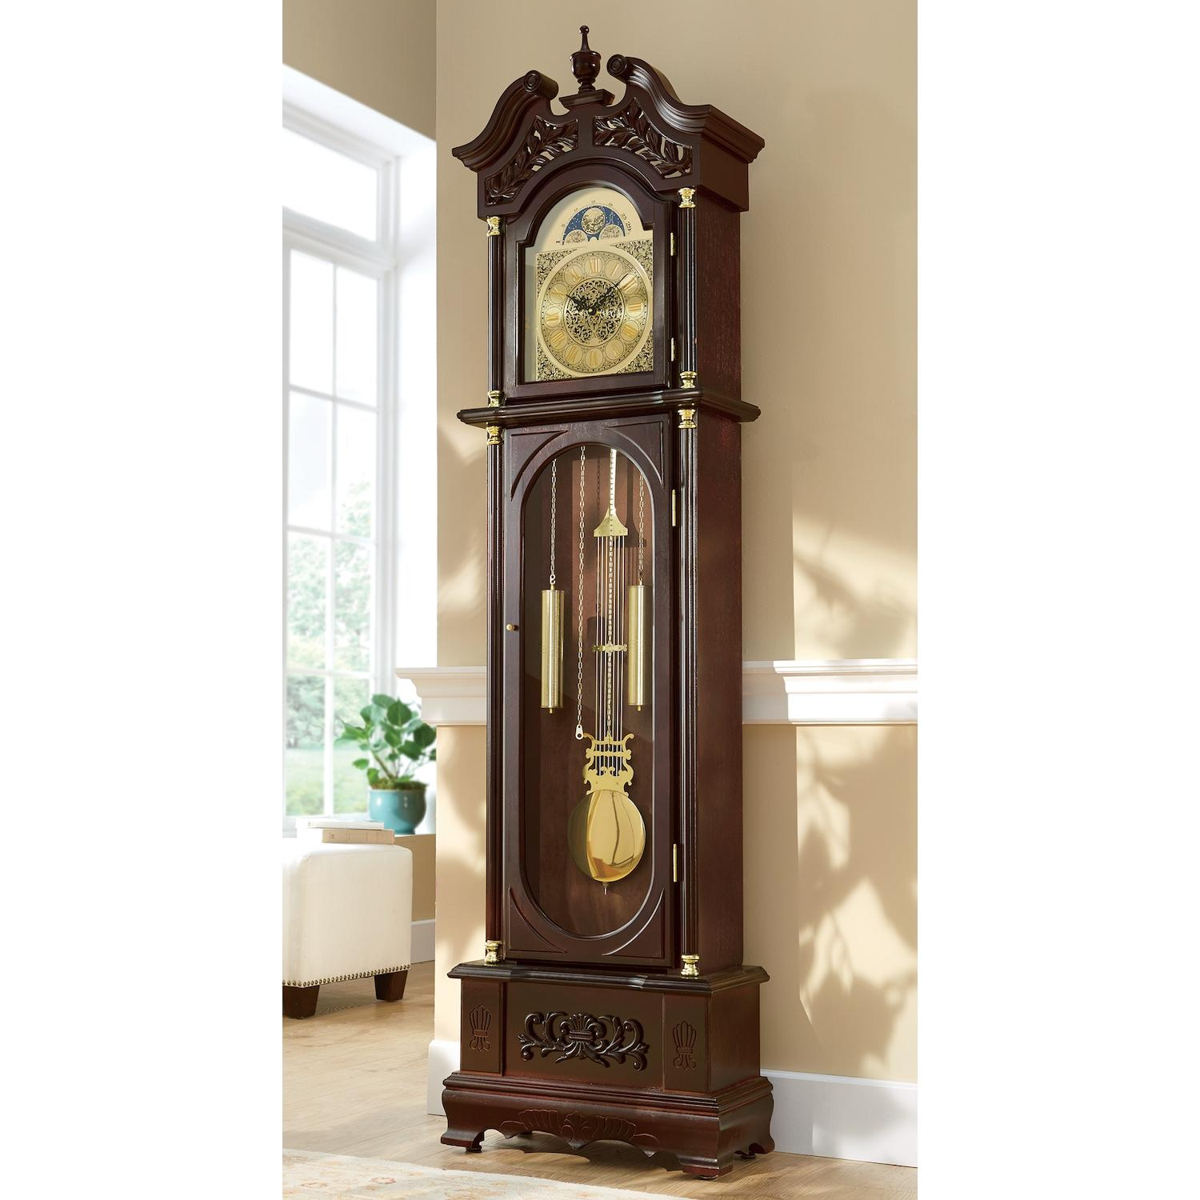
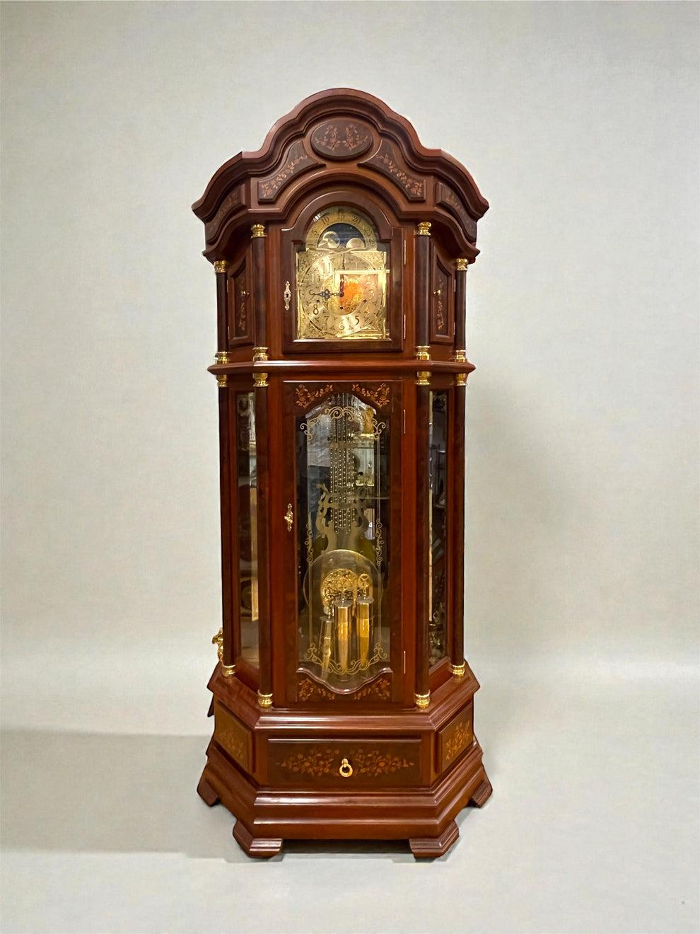
Description
Operates using gears driven by a spring or suspended weights.
Applications
- Historical timekeeping
- Decorative clocks
- Museums

4. Quartz Clock
# Source: AI Source: Provided by: [Data Path: Persons Table -> ID Column: 1, Name_En Column: Motasem Essam] -> From: [ChatGPT] on [7/17/2026]
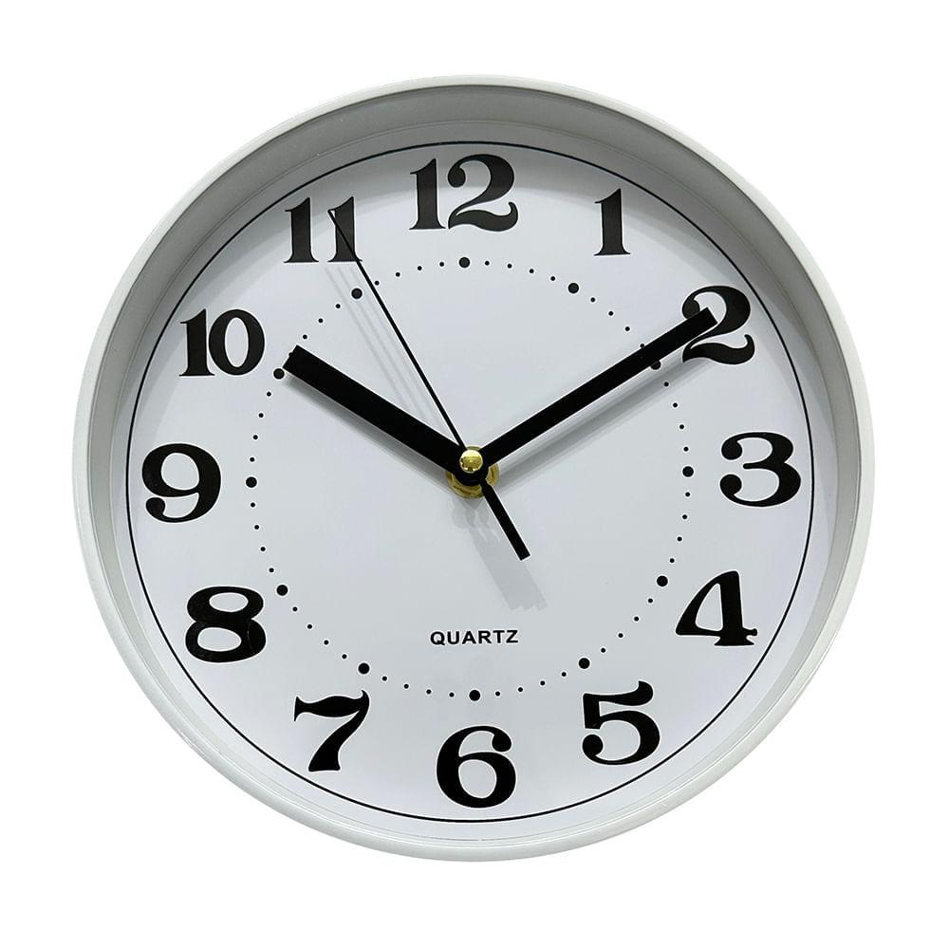
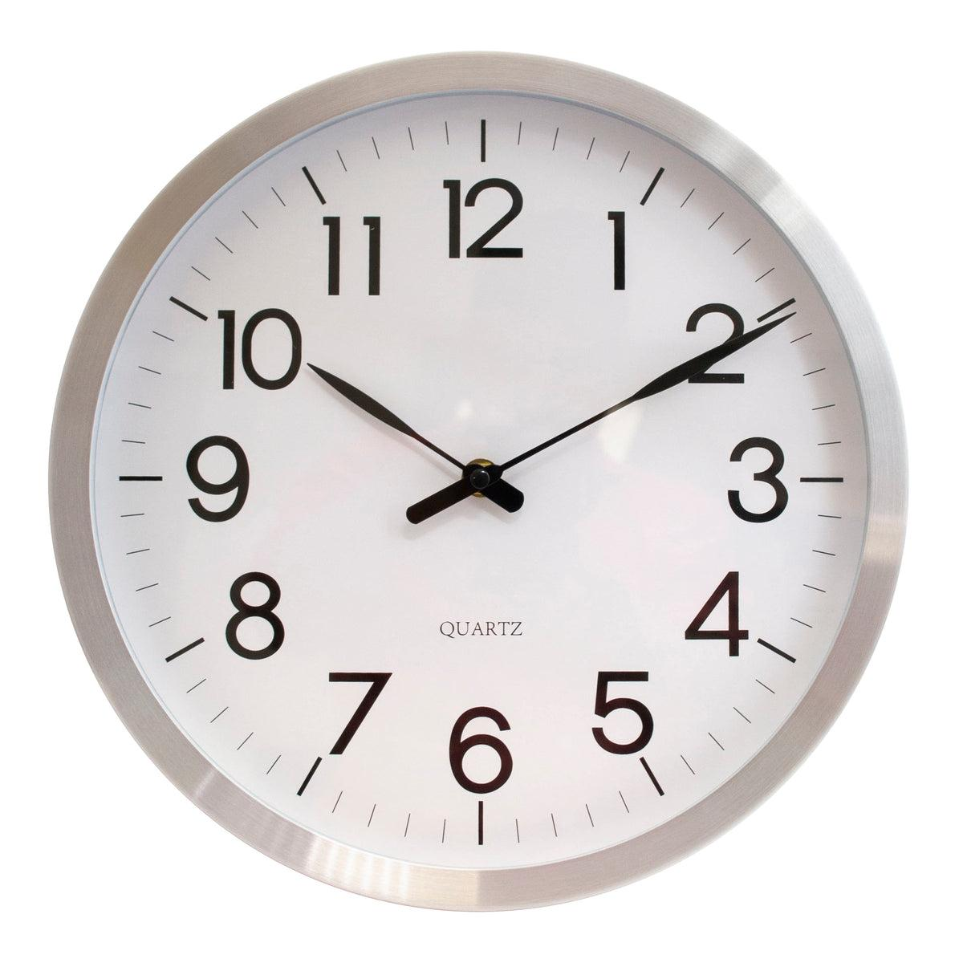
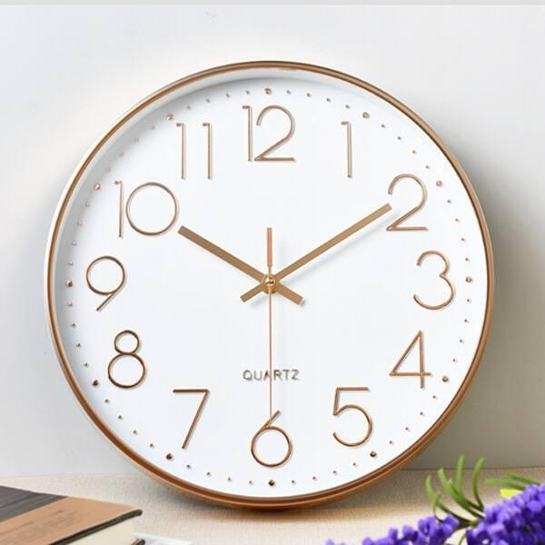
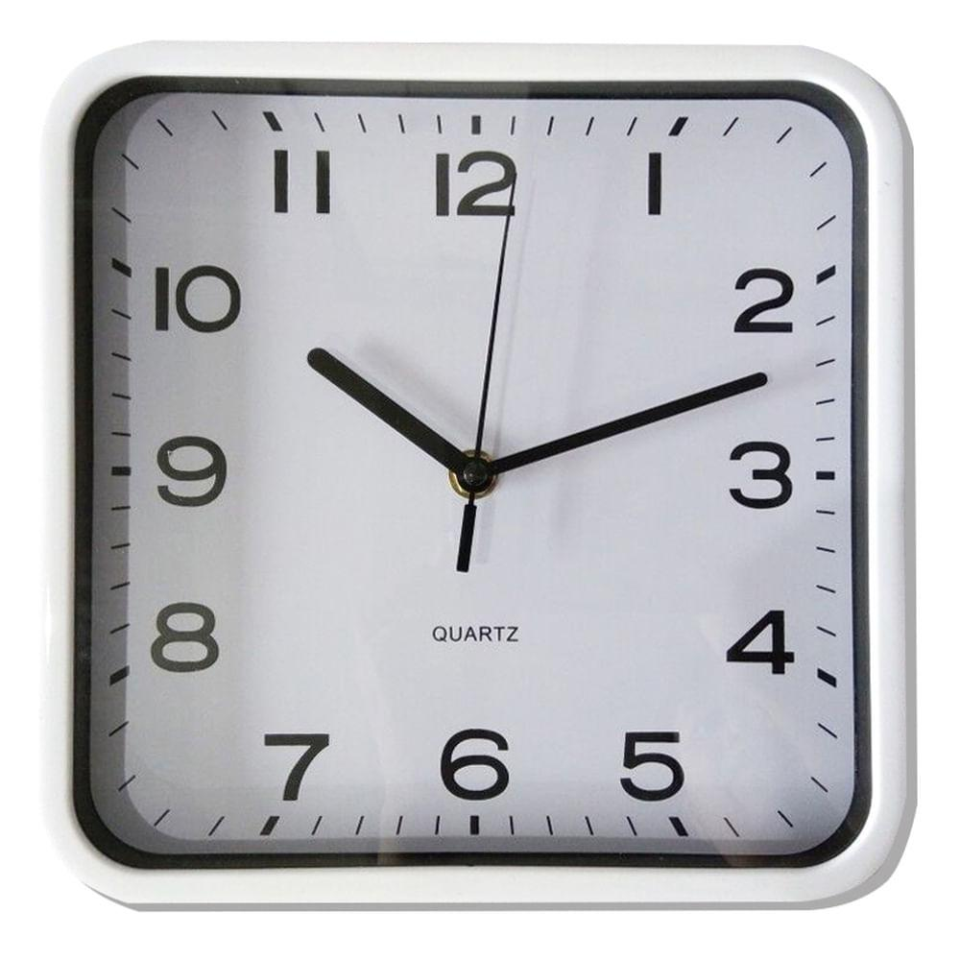
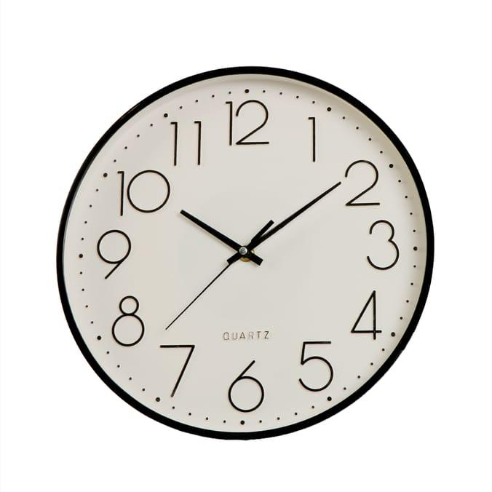
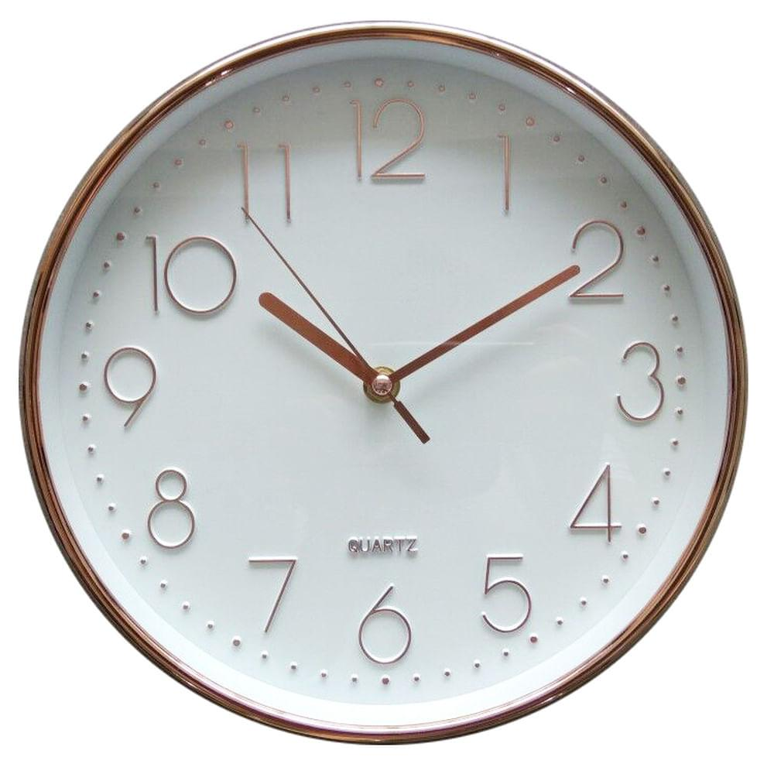
Description
Uses a quartz crystal oscillator to maintain accurate time.
Features
- Battery powered
- High accuracy
- Low maintenance
Applications
- Most modern wall clocks
- Watches
- Household clocks

5. Atomic Clock
# Source: AI Source: Provided by: [Data Path: Persons Table -> ID Column: 1, Name_En Column: Motasem Essam] -> From: [ChatGPT] on [7/17/2026]
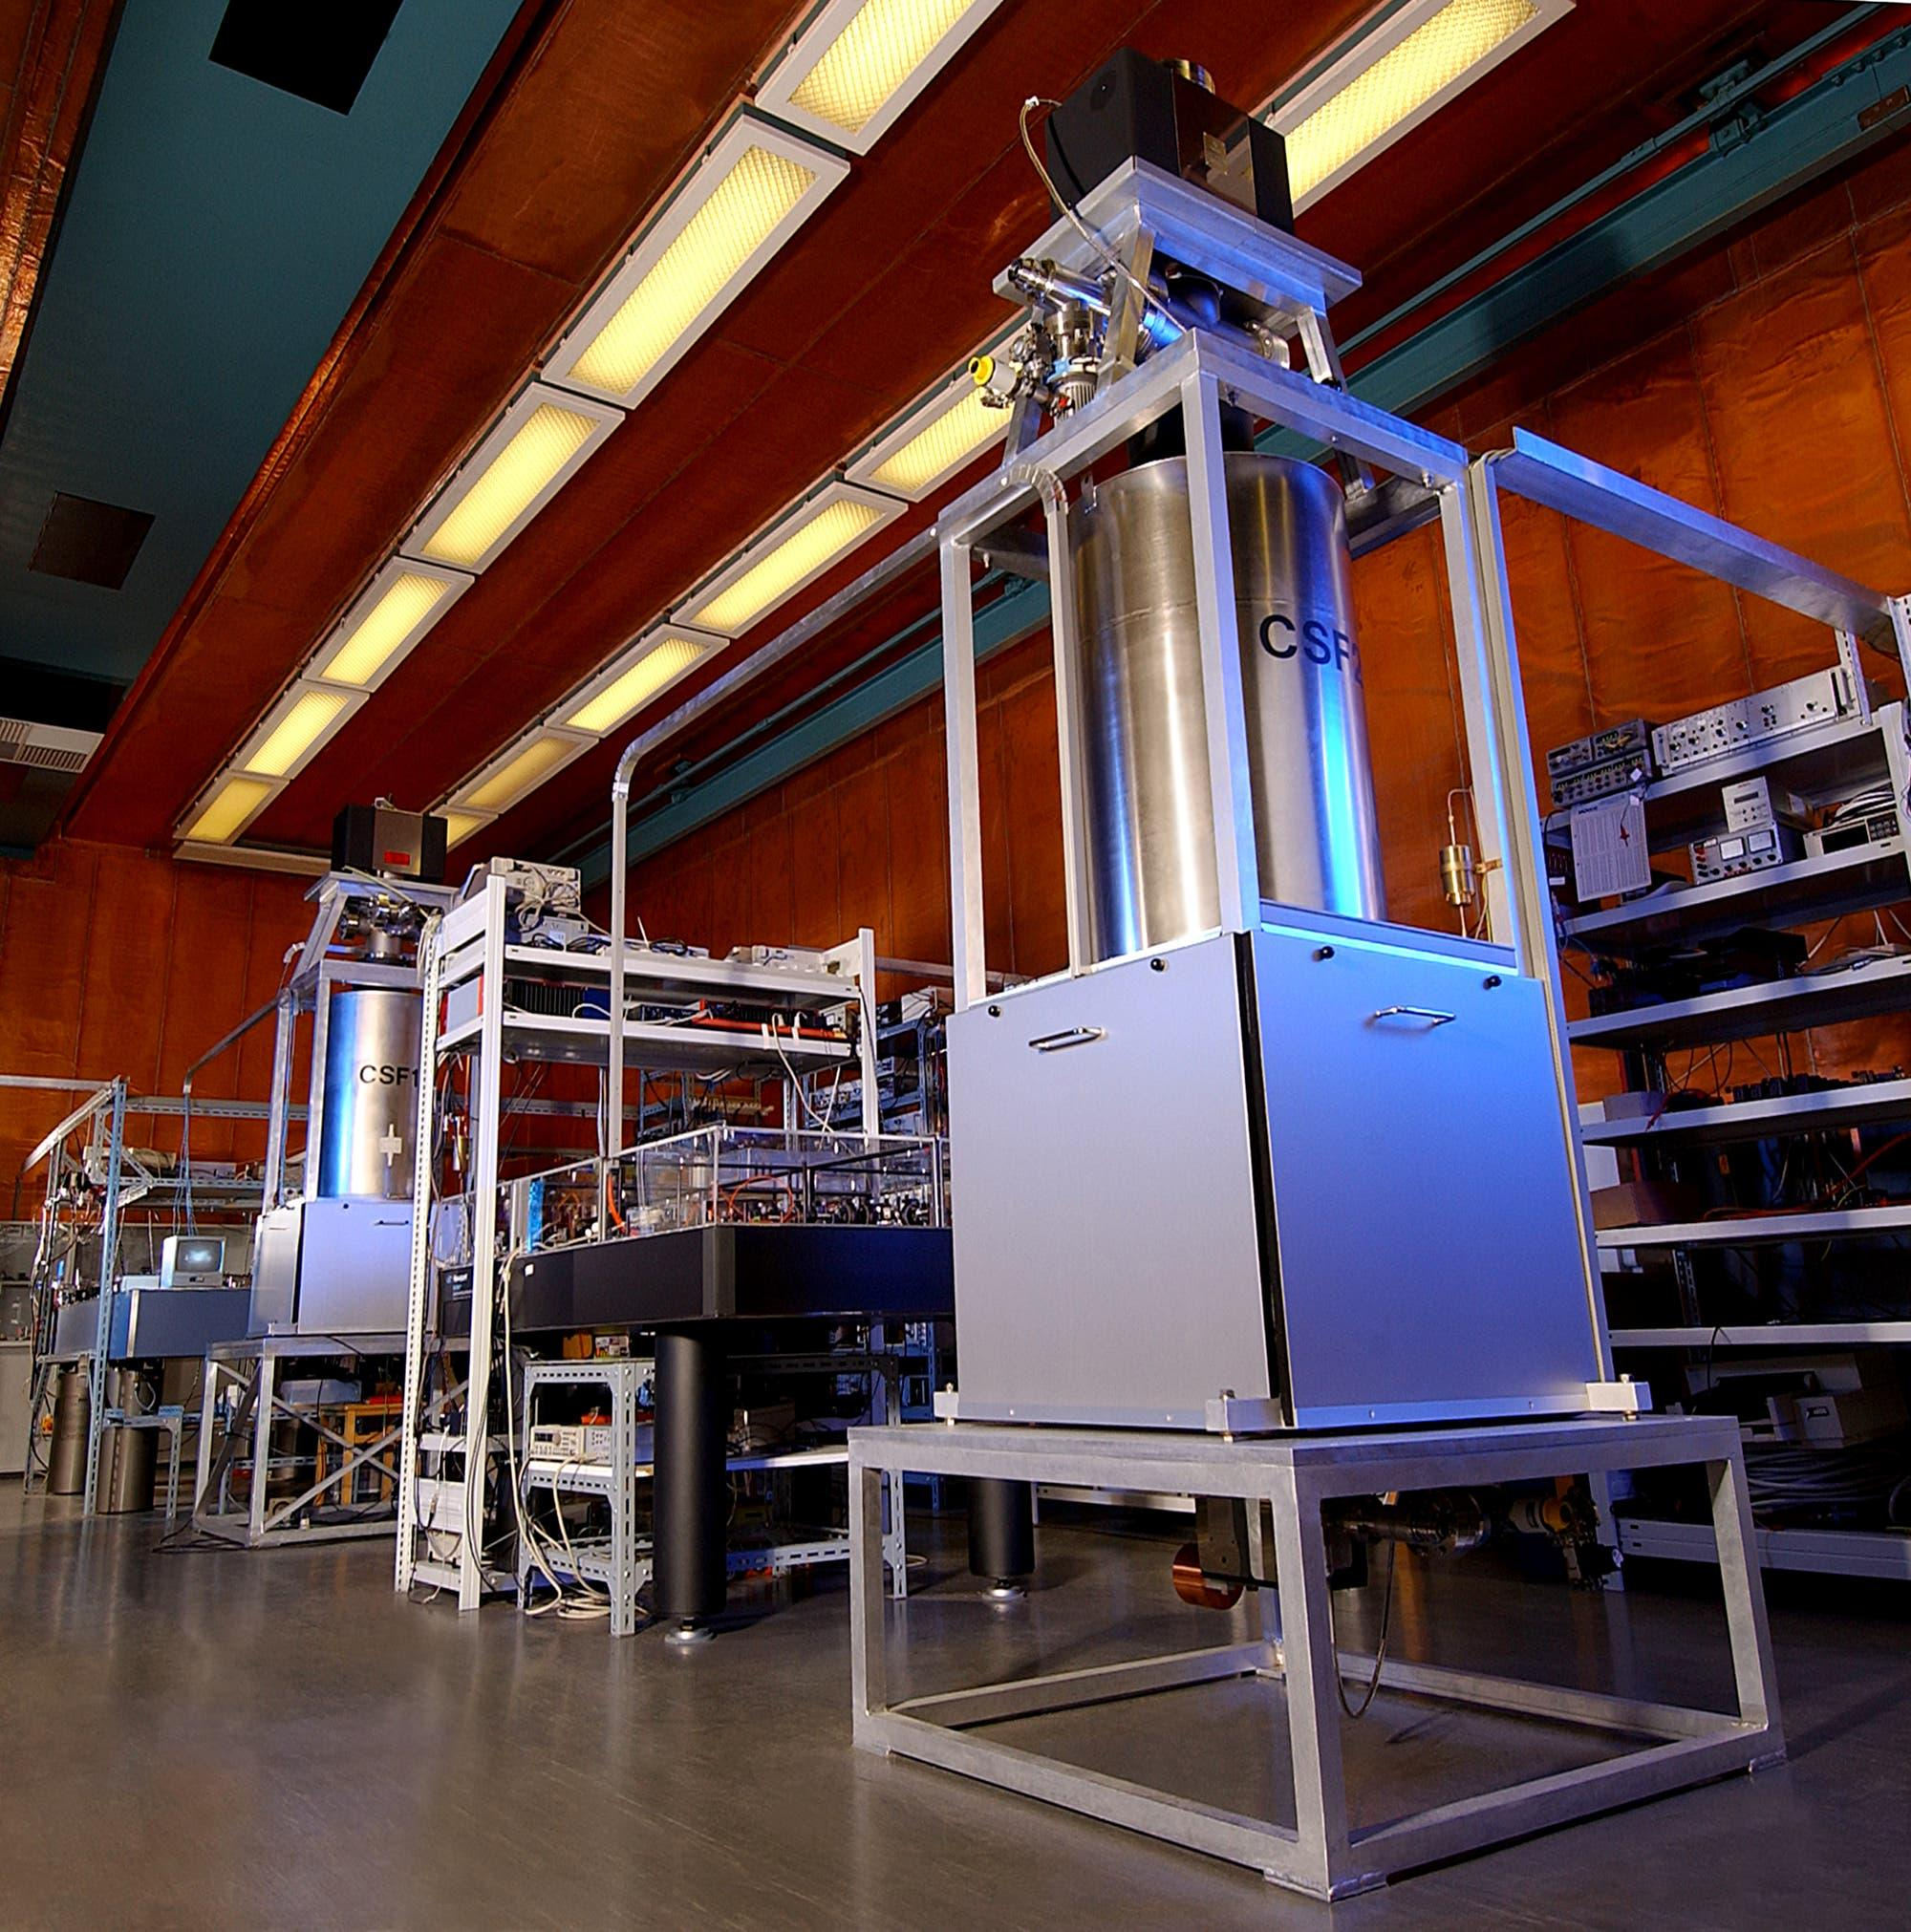
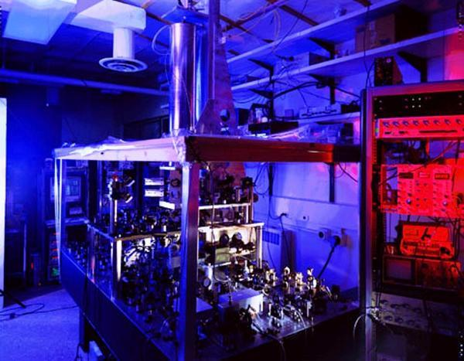
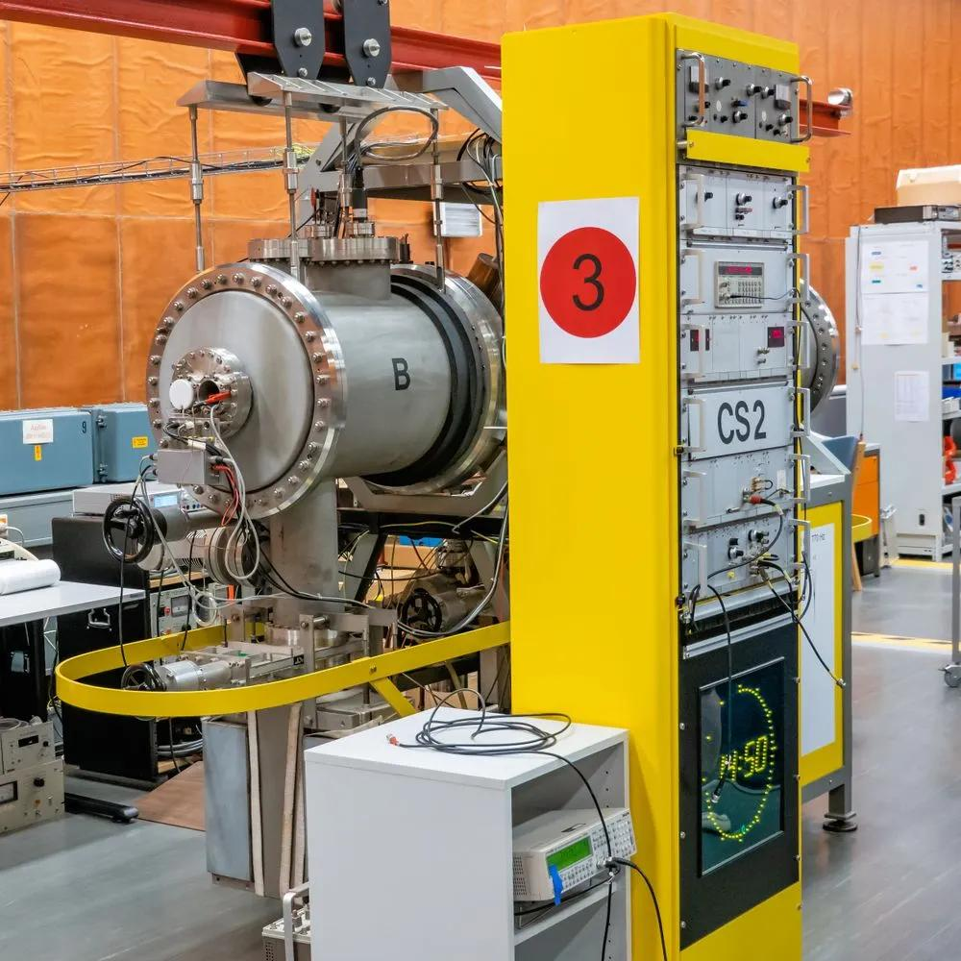
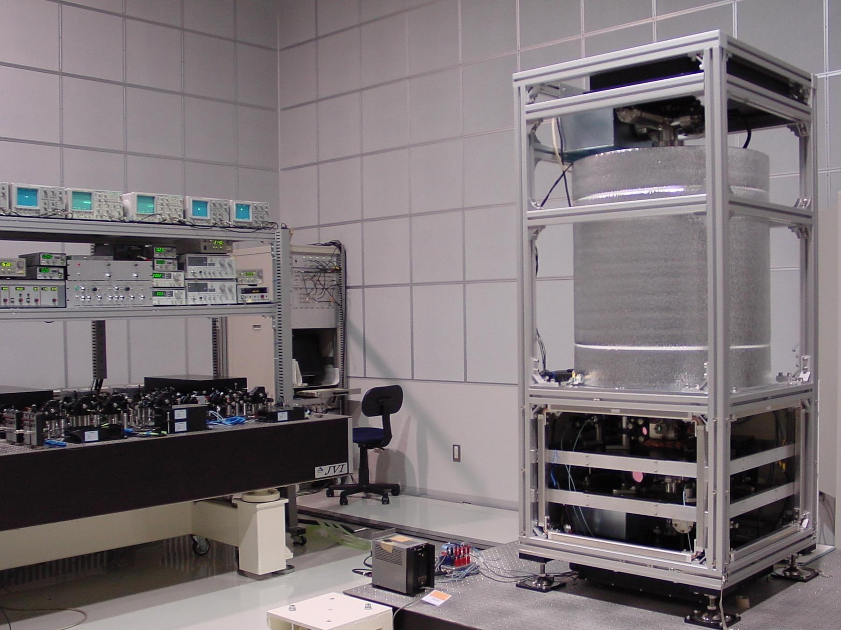
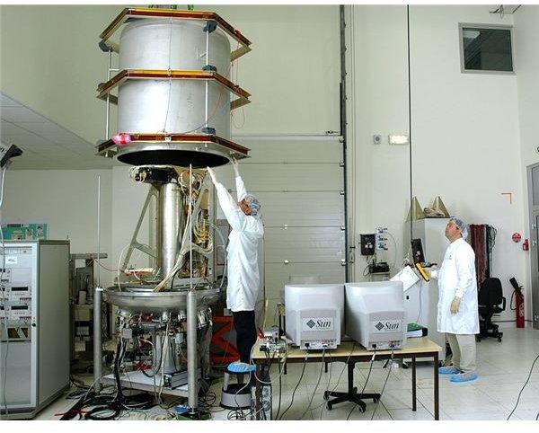
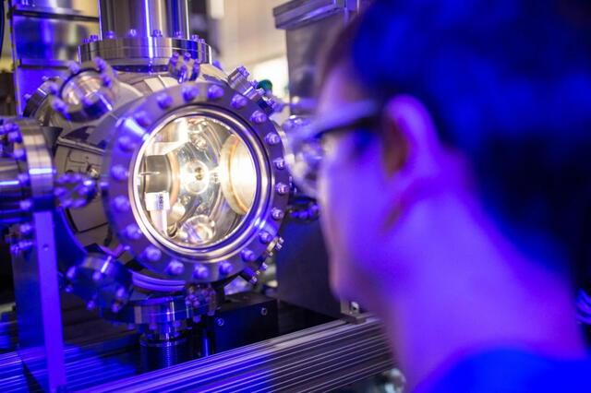
Description
Uses atomic resonance frequencies to measure time with extremely high precision.
Applications
- National time standards
- GPS satellites
- Scientific research
- Telecommunications

Time Display Formats
# Source: AI Source: Provided by: [Data Path: Persons Table -> ID Column: 1, Name_En Column: Motasem Essam] -> From: [ChatGPT] on [7/17/2026]
Common formats include:
- 12-hour format (AM/PM)
- 24-hour format
Example:
- 3:45 PM
- 15:45

Measuring Units
# Source: AI Source: Provided by: [Data Path: Persons Table -> ID Column: 1, Name_En Column: Motasem Essam] -> From: [ChatGPT] on [7/17/2026]
A clock displays:
- Hours (h)
- Minutes (min)
- Seconds (s)
Some digital clocks also display:
- Date
- Day
- Month
- Year

Resolution
# Source: AI Source: Provided by: [Data Path: Persons Table -> ID Column: 1, Name_En Column: Motasem Essam] -> From: [ChatGPT] on [7/17/2026]
Typical resolutions:
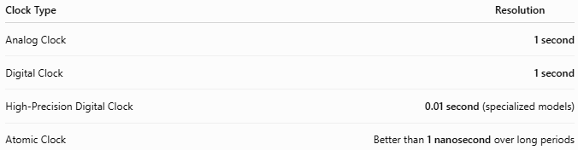
Clock Type | Resolution
Analog Clock | 1 second
Digital Clock | 1 second
High-Precision Digital Clock | 0.01 second (specialized models)
Atomic Clock | Better than 1 nanosecond over long periods

How to Read an Analog Clock
# Source: AI Source: Provided by: [Data Path: Persons Table -> ID Column: 1, Name_En Column: Motasem Essam] -> From: [ChatGPT] on [7/17/2026]
- Read the hour hand.
- Read the minute hand.
- Read the second hand (if present).
Example:
- Hour hand between 8 and 9
- Minute hand on 3
- Second hand on 12
Time:
8:15:00

How to Read a Digital Clock
# Source: AI Source: Provided by: [Data Path: Persons Table -> ID Column: 1, Name_En Column: Motasem Essam] -> From: [ChatGPT] on [7/17/2026]
Simply read the displayed numbers.
Example:
14:37:52
means:
- 14 hours
- 37 minutes
- 52 seconds

Accuracy
# Source: AI Source: Provided by: [Data Path: Persons Table -> ID Column: 1, Name_En Column: Motasem Essam] -> From: [ChatGPT] on [7/17/2026]
Accuracy depends on the clock type:
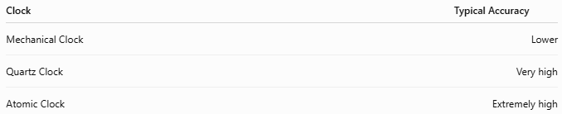
Clock | Typical Accuracy
Mechanical Clock | Lower
Quartz Clock | Very high
Atomic Clock | Extremely high

Sources of Error
# Source: AI Source: Provided by: [Data Path: Persons Table -> ID Column: 1, Name_En Column: Motasem Essam] -> From: [ChatGPT] on [7/17/2026]
Mechanical Errors
- Gear wear
- Spring fatigue
- Pendulum disturbance

Electronic Errors
- Weak battery
- Quartz aging
- Electronic failure

Environmental Errors
- Temperature changes
- Humidity
- Mechanical vibration

Human Errors
- Incorrect time setting
- Misreading analog hands

Applications
# Source: AI Source: Provided by: [Data Path: Persons Table -> ID Column: 1, Name_En Column: Motasem Essam] -> From: [ChatGPT] on [7/17/2026]
Clocks are used in:
- Homes
- Schools
- Hospitals
- Offices
- Airports
- Railways
- Laboratories
- Manufacturing
- Telecommunications
- Space research

Advantages
# Source: AI Source: Provided by: [Data Path: Persons Table -> ID Column: 1, Name_En Column: Motasem Essam] -> From: [ChatGPT] on [7/17/2026]
A clock:
- Provides continuous timekeeping.
- Is easy to read.
- Synchronizes activities.
- Supports scheduling.
- Modern quartz clocks require little maintenance.

Limitations
# Source: AI Source: Provided by: [Data Path: Persons Table -> ID Column: 1, Name_En Column: Motasem Essam] -> From: [ChatGPT] on [7/17/2026]
A clock:
- Mechanical clocks require periodic adjustment.
- Battery-powered clocks stop when batteries are depleted.
- Quartz clocks are less accurate than atomic clocks over very long periods.

Comparison with Other Time Measuring Instruments
# Source: AI Source: Provided by: [Data Path: Persons Table -> ID Column: 1, Name_En Column: Motasem Essam] -> From: [ChatGPT] on [7/17/2026]
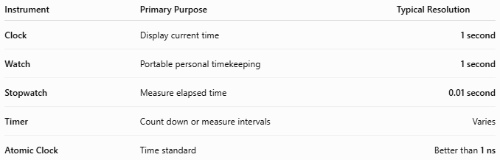
Instrument | Primary Purpose | Typical Resolution
Clock | Display current time | 1 second
Watch | Portable personal timekeeping | 1 second
Stopwatch | Measure elapsed time | 0.01 second
Timer | Count down or measure intervals | Varies
Atomic Clock | Time standard | Better than 1 ns

Care and Maintenance
# Source: AI Source: Provided by: [Data Path: Persons Table -> ID Column: 1, Name_En Column: Motasem Essam] -> From: [ChatGPT] on [7/17/2026]
To maintain accuracy:
- Replace batteries when needed.
- Keep mechanical clocks clean and lubricated.
- Set the correct time after power interruptions.
- Protect from moisture and excessive heat.
- Service mechanical clocks periodically.

Common Mistakes
# Source: AI Source: Provided by: [Data Path: Persons Table -> ID Column: 1, Name_En Column: Motasem Essam] -> From: [ChatGPT] on [7/17/2026]
- Confusing 12-hour and 24-hour time.
- Reading the hour hand before the minute hand.
- Forgetting AM/PM in 12-hour format.
- Ignoring daylight saving or time-zone adjustments where applicable.

Key Points
# Source: AI Source: Provided by: [Data Path: Persons Table -> ID Column: 1, Name_En Column: Motasem Essam] -> From: [ChatGPT] on [7/17/2026]
- A Clock continuously displays the current time.
- Common types include:
  - Analog Clock
  - Digital Clock
  - Mechanical Clock
  - Quartz Clock
  - Atomic Clock
- Most household clocks have a 1-second resolution.
- Quartz clocks are the most common due to their accuracy and reliability.
- Atomic clocks provide the world's most accurate time standard.

Conclusion
# Source: AI Source: Provided by: [Data Path: Persons Table -> ID Column: 1, Name_En Column: Motasem Essam] -> From: [ChatGPT] on [7/17/2026]
A Clock is a fundamental time-measuring instrument that continuously measures and displays the current time of day. From traditional mechanical clocks to modern quartz and highly precise atomic clocks, these instruments are essential for coordinating everyday activities, scientific research, navigation, communication, and industrial operations. Their reliability, accuracy, and widespread use make clocks one of the most important measuring instruments in human society.

